Honourable Speaker;

Honourable members of the executive committee;

Honourable councillors;

Representatives of traditional leaders;

The MM and all senior managers;

Our distinguished invited guests
- Religious leaders
- Traditional leaders
- Business sector
- All Gov Departments
- Ward committees

And the community at large

I would like to extend my sincere greetings to all of you and thankyou for coming to our council meeting.

If it wasn’t because of the tight schedule of the elections and the reconstitution of government we would have loved to have this council outside these chambers and take it to the people as an open council.

Nevertheless we are still excited to present this budget speech to council.

It is my honour and privilege to present my fourth budget Speech to council today as we mark the third financial year of our council in this term of office.

That means we are effectively left with less than 24 months as this council in this term of office. This is our second before last budget that we are presenting to you.
Perhaps one would ask, in the last 3/4 years what is it that we have been able to do to change the lives of our people for the better?

I guess this question will be more relevant in the last financial year to take stock on our achievements and shortcomings as this administration in our term of office but is also good to be always preoccupied with that question so that we don’t lose our foresight in the ball or goalpost.

But even now we can site a few achievements of this administration:

- We have inherited this municipality in a deficit but today we are sitting in a positive balance, thanks to your discipline and cooperation when we propose and implemented a very tough and painful belt tighten measures.
- We have rearranged the institution and positioned it better to respond to the challenges faced by our communities (doing away with strategic support dep, introducing risk management, strengthening internal audit unit, strengthen the SCM unit, getting more skilled personnel for water services and infra-structure etc)
- We have improved water quality through the blue drop status as well as the green drop status.
- We have completed a no of infra-structure projects that we have inherited and we were also able to introduce new regional water schemes such as Mnqumeni, Hlokozi, Ufafa, Mbhulelweni, Makhoba, Franklin, greater Summerfield etc
- We have reduced the over reliance on consultancy and strengthened capacity internally
- We have done away with the use of private water tankers and we were able to buy our own water tankers though they are not yet enough
- We have started the implementation of a R550 m (Steven Dlamini/ Bulwer dam) project to benefit thousands of our people
- Formalising the establishment of the entity (SDA) and dealing with its governance issues
- Strengthening our coordinating and supporting role to local municipalities
- Rebuilding trust with external role players such as the office of the AG and other provincial and national government departments
- And of course successfully renaming the municipality after our struggle icon, ubaba u Harry Gwala and erecting a statue.

The list is endless and of course there are still a no of challenges but our successes can’t be overshadowed but by the persisting challenges. We are determined to overcome all obstacles and deliver quality services to our people; at least we owe it to them.

Broad issues in our country and the world

As the District Municipality we do not exist in a vacuum but we exist in the country, continent and the world and therefore it is imperative that we take note of a no of developments taking place around us, negative or positive, social, political or economical because one way or the other that has an impact to our being not only as the country or district but as humanity in general.

We are meeting here today after a no of significant historic events in our country and the world.

To mention a few, just a couple of weeks ago on the 8th of March 2014 we have witnessed an unprecedented loss or disappearance of a plane from the Malaysian Airline that saw the whole world in solidarity searching for this plane that was carrying about 12 crew members and 227 passengers from about 14 nations

And sadly so up until now there is still no trace of that plane, more than 200 people just perish in the air.

Again on the 17th of April 2014 a South Korean ship sank with nearly 300 people including school children. Many disappeared and some were found dead and some who were lucky were rescued alive.

In Europe the West and the East is in confrontation on the Ukraine question where Russia is alleged of invading a territory of Ukraine. The continued confrontations between the US together with some countries from the West against Russia poses a challenge to stability in the world and as a consequence result to a volatility of some economies in the world and as is always the case, the small economies including ours become the worst victims.

As if all the above was not enough, just in our continent, acts of terrorism still persist further complicating our situation. This perpetuates the already existing challenges of underdevelopment, poverty, diseases, maladministration and civil wars.

The abduction of the young and innocent Nigerian school girls by the Boko Haram (Islamist organisation) under the pretence of the religious conflicts and demand to release prisoners is not only a terrorist act but the most barbaric act that the radical formations have ever done.

Unfortunately this happens at the time when we celebrate Africa Day.

Back home we are presenting this third budget speech under the following context:

20 years of Freedom and Democracy

Just couple of weeks ago we were celebrating our 20 years of freedom and democracy as we had our first democratic elections on the 27th of April 1994.

These celebrations gave us an opportunity to examine the road that we have traversed ever since our democratic break through and dawn of democracy in our country but not only that but also to reflect about where we come from as a nation in terms of apartheid and colonialism in this country.

This reminded all of us and taught the young ones that our freedom was not free but was attained through sweat and blood.
These celebrations reminded us that 20 years might sound like a long time but nothing as compared to the 342 years of colonialism and apartheid in this country.

For any reasonable person you would imagine and understand that it won’t be easy to reverse the injustices of more than 342 years only in two decades but we need even more time to transform our society.

I just want to take this opportunity at this point and thank the MM, the senior management team and all the officials who have supported us through all these activities.

If I may repeat what I said in the executive committee, you have gone an extra mile and worked beyond the call of duty and for that we are deeply humbled, your efforts will never go unnoticed.

But I think it is also proper to thank all other stakeholders, Political leadership, traditional leaders, religious leaders, government departments and all who has made a contribution to these programs.

I am acknowledging all of you because your contributions have made us to be number one in the province. When the Premiers office was doing an assessment your region/ your district became the best district in terms of the programs of the freedom flame in particular the carnival walk.

ANC victory in the last National and provincial general elections
On the same vein, allow me honourable speaker, honourable members and colleagues to also take this opportunity and congratulate the ruling party for winning the elections again, both in the Province and at a National level.

Others laughed at me in the executive committee when I said if you can’t beat them join them.

Despite the liberal offensive agenda by the opposition and the Medea but the ANC still emerged victorious.

We might have declined a bit in terms of percentage but there is still one winner and that is the African National Congress.

For me that was a testimony that no matter how hard people can attack the ruling party and its leadership but the majority of our people know the truth and still regard the ANC as their only beacon of hope and political home.

I can say today with confidence and authority that the people of South Africa trust and support the ANC, our policies and our transformation agenda. We dare not fail them.

We were all encouraged and inspired by the tone of the President in his acceptance speech in the inauguration that the next five years will be different; there will be no room for laziness and mediocrity.

The ANC led government will implement radical programmes to grow the economy so that we respond to the triple challenges

I would like to congratulate the President of the ruling party who is also the President of the Republic and all those men and women appointed to various portfolios.

I think it is more important to our sector of local government to acknowledge the appointment of the former Minister of finance, Mr Pravin Gordan as a serious and strategic move by the President to really shakeup things in the sector given the current minister’s track record in treasury.

It is also historic that for the first time after our democratic breakthrough we have an African minister leading finance, Minister Nhlanhla Nene.

I was particularly happy to learn that there is a new ministry for water and sanitation, meaning as districts we can liaise directly with that ministry to fastrack service delivery.

In the Province we must congratulate the Premier for his reappointment and we have no doubt that he will take the province to greater heights.

We have also seen continuity and a bit of change in the province and that on its own will ensure stability and direction to our programs. Even the new appointments are very matured because it’s seasoned cadres of the movement both politically and in government.

It is important to also to welcome the reappointment of MEC Dube-Ncube, to the department to ensure stability and continuity in the Department.

2016 local government elections

We are now working towards the 2016 local government elections but when we do so we are not necessarily having sleepless nights thinking about re-election but we are at all times driven by the desire to improve the lives of our people for the better.

We as the ANC we have always said that we are striving for a democratic national society (NDS) and we will only achieve that through the successful implementation of the national democratic revolution (NDR).
The NDS is a society where there is quality public education, quality and affordable public health care, peace and stability, water, proper sanitation, electricity, roads, houses etc and where there is no poverty, unemployment or inequalities.

IDP and Budget for 2014/15 financial year

On behalf of the executive committee, as we are about to present before council, consider and adopt the reviewed and amended IDP as well as the budget for the new financial year.

I am very happy to indicate that we have had a very successful and vibrant IDP and Budget road shows.

The first round of the IDP/Budget roadshows was conducted in 2013 in October/November and after having considered all the issues raised by all our people and stakeholders we had to go back again this year in March/ April 2014.

I would like at this point to take this opportunity and thank every one of you, leadership, management and officials who have made it possible for these engagements with our people to take place in a very meaningful and educative manner.

Public participation remains the pillar of our young democratic government.
As our predecessors said in 1955 in the Congress of the people that, “the people shall govern”.

What we will be presenting here today is a true reflection of the aspirations of our people across the District.

This is one of our strengths as the District to keep a constant interaction with our people even when it is very difficult to do so and that has helped us to minimise the service delivery protests, though we did have some isolated incidents.

Integrated development plan
(Annual review and amendment of the integrated development plan)

In line with chapter 5 (a) and (b) of the Municipal systems act and regulations 32 of 2000 that says

- A municipal council must review its integrated development plan-
- Annually in accordance with an assessment of its performance with measurements in terms of section 41 and
- To the extent that changing circumstances so demand, and
- May amend its integrated development plan in accordance with a prescribed process

Section 35 (1) of the municipal systems act goes further to say:

- An integrated development plan adopted by the council of a municipality –
- Is the principal strategic instrument which guides and informs all planning and development, and all decisions with regard to planning, management and development, in the municipality

Included in our IDP and budget this time around as our key and strategic areas are the following:

Under council, the executive committee and all other oversight structures of council, we want to strengthen all the political offices in terms of necessary skills such as coordination, research, communication, financial management etc so as to ensure effective monitoring and oversight role of council.

We will do the above through deploying the capable individuals to support these offices but also to continue with the capacity building of individual councillors including traditional leaders.

In the office of the MM, the executive committee has made an undertaking to continue to strengthen that office so that the Municipal manager can concentrate more on strategic issues and give overall strategic management to the municipality without being distracted by operational issues.

And we shall do so by ensuring that we support management to appoint an operations manager in the office of the MM, strengthen the internal audit unit, risk management unit and other key areas that are housed in the office of the MM.

In the budget and treasury office (finance), we have invested a lot of resources over the years to turn around the situation particularly in the SCM unit and other directorates.

Right now the main issues that have been included in the IDP and Budget and that will remain our key strategic priorities in the next few years to come is:

- To enhance and expand our revenue base and ensure that we build capacity to collect what is due to us as the municipality so that we can in return invest back those resources particularly to operations and maintenance
- To ensure that we eliminate irregular expenditure and unauthorised expenditure to zero, I don’t even want to speak about fruitless and wasteful expenditure because that one has severe consequences.
- The finance department working together with the office of the MM and all other line departments to ensure good and proper contract management, keep and maintain registers such as deviation register etc
Under corporate services department, our main priority this time around apart from the normal institutional support role that this department plays such a recruitment, training, labour relations, council support, auxiliary services etc. in the next few months we must strive to professionalise our workforce, let them know our strategic objective and vision, inspire discipline and efficiency.

Above all we must strive to have zero queries from the auditor general particularly on ICT that was a major area raised by the AG in terms of good governance and control

We must also find innovative ways of improving the culture of the institution; either you talk about late coming, absenteeism, Batho Pele, going an extra mile in providing the service to our people, working beyond the call of duty etc
Can we as management inspire that culture and that would only happen if we lead by example in all respects.

And I must say that we do have confidence on you, you can do it. It’s just that you will need to do the extra ordinary to realise that kind of discipline and sense of urgency and service to our employ.

Under social services, this department among others deals with planning, IDP, Performance management, environmental management, disaster management, sport development and youth, women, disabled people development etc

In the next financial year as much as we acknowledge all areas that fall under this department as equally important but we will pay more attention on the functionality of the various forums to ensure that interests of various sectors are really taken care of by the municipality with an emphasis on development and empowerment of the designated groupings.

We will also continue to work with our local municipalities to plan and formalise out towns with a view of uplifting the faces of our towns and attracting more investments and creating more job opportunities for our young people and women.

We will also continue to strengthen the youth unit, introduce the women’s desk to link up directly with the new ministry on women in the Presidency.

We shall also introduce new sport development programs to improve our competitive strength as the district and develop and expose talent among young people.

In the near future we are planning to have an annual mayoral tournament that will include some professional teams from the province such as Golden arrows, AmaZulu etc to play against our district teams.

Under Infra- structure, our IDP and budget does take into account the improvements and progress that we have already made but as council we do note that we still have a long way to go to perfect our systems and processes.

The main worries in this department that constitute our ke priorities going forward is:

- Forward planning
- Project management
- Contract management
- Social facilitation
- Ensuring visible and speedy impact on our multi-year regional water schemes.
If we can master the few above we would see speedy implementation of some of our projects and improved management and expenditure on our conditional grants.

Lastly under water services, this is our co-function as the District Municipality. And we welcome the introduction of a new ministry for water and sanitation and we now know where to direct our frustrations as the district.

But we can’t just throw money to all our problems but we do need to put our house in order and improve in the areas where we are not yet doing well.

This department is mainly responsible for planning, design, operation and maintenance.

Right now, the major outcry out there is not necessarily lack of service delivery in terms of water but more so a challenge of functionality of our water schemes. Of course our department is doing its best to respond to those issues but they will always be a room for improvement.

We must pay more attention in the following areas:

- Functionality of our water schemes
- Strengthen our customer care unit by providing more personnel and modern systems
- Improve our turnaround time when there are challenges
- Improve communication with our consumers
- Attend radically to the installation of mitres as part of our revenue enhancement strategy
- Ensure that schools and other public facilities and businesses are prioritized as they are not indigent

Our priorities in the entity the SDA, council took a conscious and deliberate decision to create a vehicle to drive local economic development. The SDA is tasked fundamentally with two strategic responsibilities:

- Working together with other stakeholders to drive tourism in the district and
- To ensure local economic development of our district

We have dealt with issues of governance in the SDA though we are still saddened by the passing away of one of the members of the board who was very instrumental on issues of governance, the late Ms Zandile Mnyandu, May her soul rest in peace.

We must then fast track her replacement in the board and we can’t compromise quality in terms of leadership, governance, rural economic development exposure and financial management.

Under the theme of rural development and agrarian revolution we must use our potential as the district to produce food not only for human consumption but for commercial purposes and in the process creates job opportunities.

Already we have an understanding with the provincial government that all the districts must develop entities to drive the nutrition program in schools. We have established partnership with ILembe District Municipality in this regard and continue to work with our local cooperatives.

We will continue with skills development program that we have started and we are happy that the minister for higher education Dr. Blade Ndzimande has been re-appointed to the department because we have already spoken to him about a no of initiatives on top of what we are already doing with higher education.

We must also take advantage to engage the new ministry on small businesses and see what we can do together in empowering our people.

The issue of the economy require strong and visionary leadership and I think we do have what it takes, as long as we are determined to move faster.

Financing and implementing our IDP

Then on annual basis we finance our priorities that are in the IDP through the budget.

I can say with authority that we have always tried to align our budget to the IDP as our principal and strategic planning tool as the municipality.
The organisational structure is also informed by this IDP and affordability in terms our budget.

Then in terms of the law, within a reasonable period (14 days) after the approval of the Budget we then craft a service delivery budget and implementation plan (SDBIP) for all directorates.

Purpose for the presentation of the Final draft Budget to council

On behalf of the Executive committee of council I am hereby tabling the 2014/15 Medium Term Revenue and Expenditure Framework final draft budget for consideration and approval by Council.

Background and discussion

In terms of section 16 (1) of the Municipal Finance Management Act the Council of a Municipality must for each financial year approve an annual budget for the Municipality before the start of that financial year.

The MFMA in chapter 4, section 16 (1) states categorically clear that the council of a municipality must for each year approve an annual budget for the municipality before the start of that financial year.

Then section 16 (2) goes further to say that, in order for a municipality to comply with subsection (1), the mayor of the municipality must table the annual budget at a council meeting at least 90 days before the start of the budget year

In terms of section 17 of the MFMA;

An annual budget of a Municipality must set out realistically anticipated revenue for the budget year from each source and appropriate expenditure for the budget year under the different votes of the Municipality.
- Presented below are the salient features of the tabled budget.

REVENUE

The total budget amounts to R551m. This income is derived mainly from Government Grants & Subsidies (i.e. MIG & Equitable Share).This has been allocated as follows to the operational and capital budget;

- Operational Budget R293m
- Capital Budget R258m

Table1: Revenue

REVENUE | 2014/15 BUDGET
Operational Grants & Subsidies | R 249m
Capital grants & subsidies | R 245m
Own Revenue | R 57m
TOTAL | R 551m

Chart 1: Revenue Sources

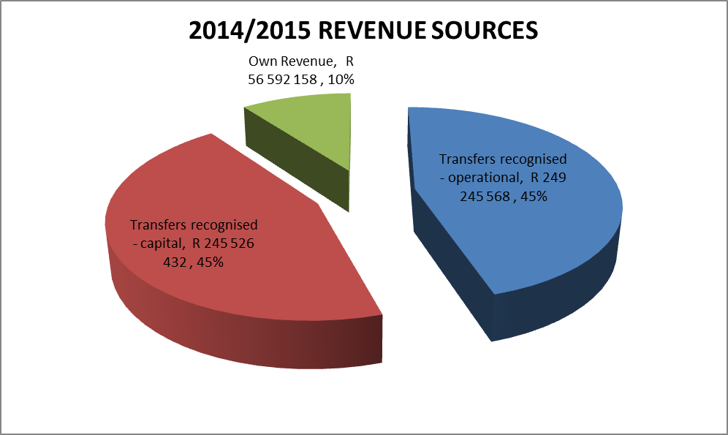

Table 2: Detailed Revenue Sources

REVENUE
NATIONAL GRANTS | 2014/15 | 2015/16 | 2016/17
EQUITABLE SHARE | R 230 622 000 | R245 003 000 | R 259 532 000
MUNICIPAL INFR GRANT | R 183 882 432 | R 192 442008 | R 201 488 259
MUNICIPAL INFR GRANT (PMU) | R 3 145 568 | R 3 291 992 | R 3 446 741
REGIONAL BULK INFRASTRUCTURE GRANT | R 28 200 000 | R 30 000 000 | R 100 000 000
RURAL ROADS ASSETS INFRASTRUCTURE - GRANT | R 2 044 000 | R 2 084 000 | R 2 163 000
MUNICIPAL SYSTEM IMPR GRANT | R 934 000 | R 967 000 | R 1 018 000
FINANCE MANAGEMENT GRANT | R 1 250 000 | R 1 250 000 | R 1 300 000
EXPANDED PUBLIC WORKS PROGRAMME | R 2 729 000 | R 0 | R 0
ENERGY EFFICIENCY & DEMAND SIDE MNGT GRANT | R 3 415 000 | R 3 000 000 | R 5 000 000
MUNICIPAL WATER INFRASTRUCTURE GRANT | R 22 800 000 | R 43 500 000 | R 109 118 000
RURAL HOUSEHOLD INFRASTRUCTURE GRANT | R 4 500 000 | R 5 000 000 | R 0
TOTAL | R 483 522 000 | R 526 538 000 | R 683 066 000
PROVINCIAL GRANTS
Development Planning Shared service | R 250 000 | R 1 100 000 | R 400 000
Small Town Rehabilitation | R 11 000 000 | R 0 | R 0
Corridor Development | R 0 | R 3 000 000 | R 3 000 000
SUBTOTAL | R 11 250 000 | R 4 100 000 | R 3 400 000
OWN REVENUE
Service charges - water revenue | R 31 719 209 | R 33 519 605 | R 36 201 174
Service charges - sanitation revenue | R 13 593 947 | R 5 418 605 | R 16 652 094
Interest earned - external investments | R 2 600 000 | R 2 000 000 | R 2 000 000
Interest earned - outstanding debtors | R 5 179 000 | R 5 593 320 | R 6 040 786
Other revenue | R 3 500 000 | R 500 000 | R 1 000 000
SUBTOTAL | R 56 592 158 | R 57 031 530 | R 61 894 053
TOTAL REVENUE | R 551 364 158 | R 587 669 530 | R 748 360 053

The water & sanitation tariffs are proposed to increase by 6% considering economic viability of Harry Gwala District Municipality for the ensuing year. The proposed tariff increase is at 6%, which is below the inflation rate of 6.2% as forecasted by the National Treasury.

Chart 2: 2014-15 MTREF Budget Summary

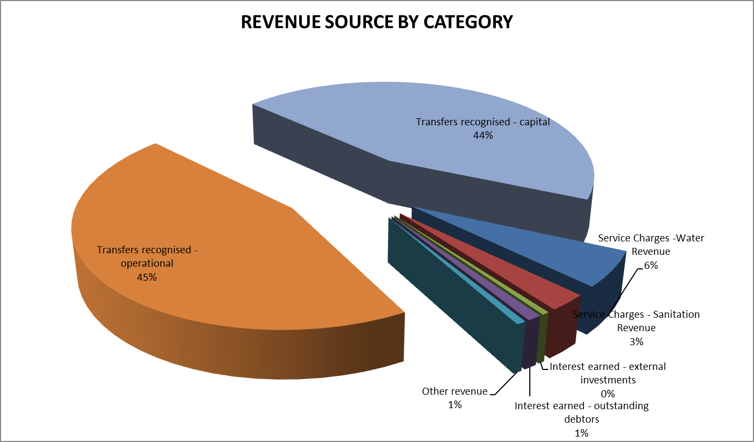

Chart 2 above presents the budget summary for the 2014-15 budget year categorised by revenue sources.

OPERATIONS BUDGET

The operating expenditure budget for the 2014/15 budget is R293m.

Chart 3: 2014-15 MTREF Operational Budget Per Vote

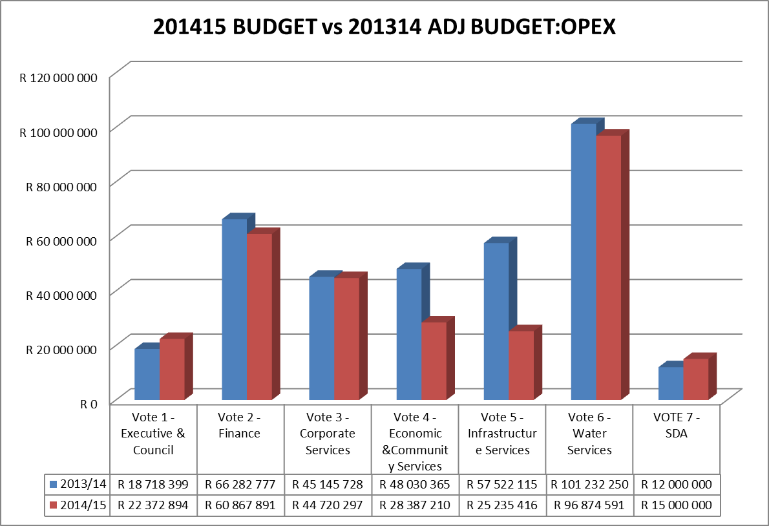

Chart 3 above presents a comparison between the adjusted and the 2014/15 Draft operational budget. The detailed line items providing operational projects as well as operational expenditure have been inserted in the table below. The comparison indicate significant decrease in operational budget by R43m, this cost containment is intended in repositioning the municipality to an improved liquidity position.

The following are the highlights of the special programmes projects.

DESCRIPTION | 2014/15 | 2015/16 | 2016/17
SPORT DEVELOPMENT | R 3 750 000 | R 5 006 500 | R 5 276 851
ICT HUB | R 850 000 | R 900 150 | R 949 658
RURAL HORSE RIDING - GAMES (SUMMER CUP) | R 1 445 000 | R 471 255 | R 497 174
DISABLED PROGRAMMES | R 357 680 | R 378 783 | R 399 616
YOUTH DEV EMPOWERMENT PLAN | R 300 000 | R 317 700 | R 335 174
BURSARIES-COMMUNITY | R 300 000 | R 317 700 | R 335 174
CUBA BURSARIES | R 200 000 | R 211 800 | R 223 449
WOMENS DAY CELEBRATION | R 200 000 | R 211 800 | R 223 449
MENS FORUM AND CAPACITY BUILDING | R 200 000 | R 211 800 | R 223 449
GOLDEN GAMES | R 200 000 | R 211 800 | R 223 449
BACK TO SCHOOL CAMPAIGN | R 100 000 | R 105 900 | R 111 725
TO ATTEND UMKHOSI WOMHLANGA | R 50 000 | R 52 950 | R 55 862
ELDERLY FORUM MEETING | R 10 000 | R 10 590 | R 11 172
TOTAL | R 7 962 680 | R 8 408 728 | R 8 866 202

Refurbishment in LM’S

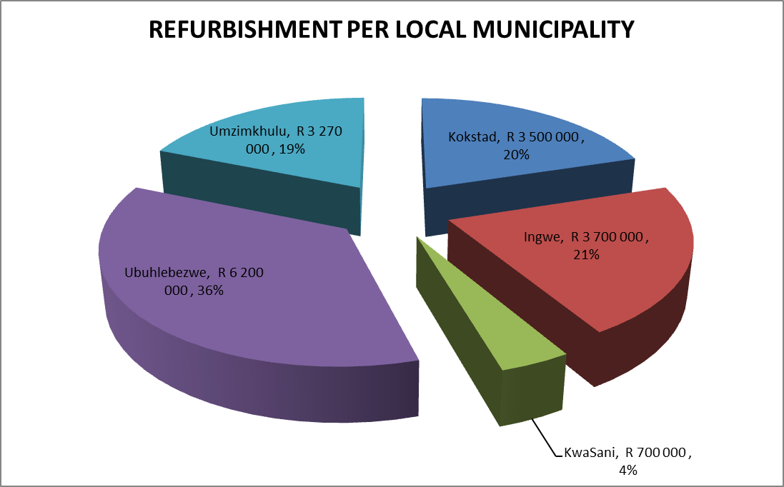

REFURBISHMENT BUDGET PER LOCAL MUNICIPALITY

CAPEX BUDGET

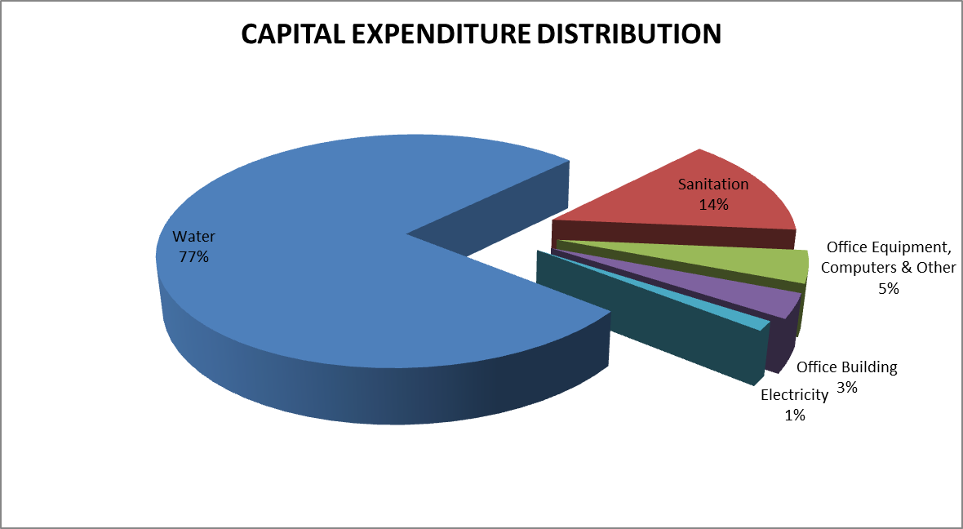

CAPEX BUDGET BY TYPE
 | BUDGET
Water | R 198 931 076
Sanitation | R 36 177 956
Office Equipment, Computers & Other | R 11 484 394
Office Building | R 8 752 399
Electricity | R 3 415 000
Total | R 258 760 826

CAPITAL DISTRIBUTION PER LOCAL MUNICIPALITY

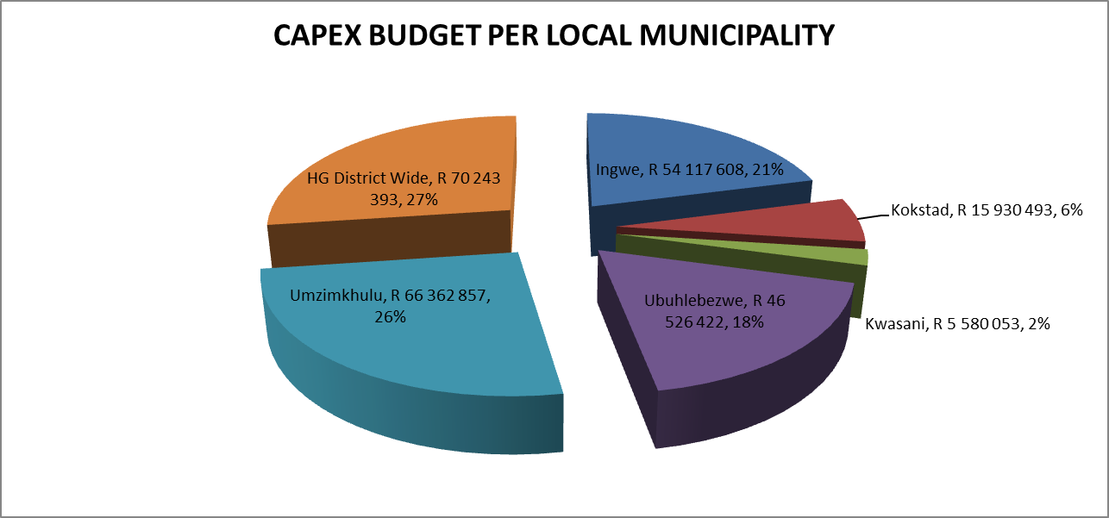

CAPEX BUDGET PER LOCAL MUNICIPALITY

PROJECTS | BUDGET
 | 2014/15 | 2015/16 | 2016/17
Ingwe | R 54 117 608 | R 55 119 277 | R 80 635 000
Kokstad | R 15 930 493 | R 11 355 451 | R 10 000 000
Kwasani | R 5 580 053 | R 13 850 819 | R 10 000 000
Ubuhlebezwe | R 46 526 422 | R 47 274 841 | R 34 500 000
Umzimkhulu | R 66 362 857 | R 69 089 874 | R 65 000 000
HG District Wide | R 70 243 393 | R 73 500 000 | R 209 118 000
TOTAL | R 258 760 826 | R 270 190 262 | R409 253 000

CAPITAL BUDGET PER LOCAL MUNICIPALITY
INGWE PROJECT LIST

PROJECTS | 2014/15 | 2015/16 | 2016/17
Bulwer to Nkelabantwana and Nkumba Water | R 7 593 686 | R 8 000 000 | R 20 000 000
Greater khilimoni | R 16 935 900 | R 10 000 000 | R 20 200 000
Khukhulela water | R 3 425 287 | R 8 818 277
Kwanomandlovu water project | R 13 477 216
Mangwaneni water supply | R 2 685 519
Mbhulelweni water supply | R 3 000 000 | R 18 301 000 | R 11 135 000
Ingwe household sanitation project | R 7 000 000 | R 5 000 000 | R 4 300 000
Bulwer donnybrook water supply scheme project | R 7 593 686 | R 5 000 000
Creighton Water Supply |  |  | R 15 000 000
Donny Brook Bulk Sewer |  |  | R 10 000 000
TOTAL | R 54 117 608 | R 55 119 277 | R 80 635 000

KOKSTAD PROJECT LIST

PROJECTS | 2014/15 | 2015/16 | 2016/17
Eradication Of Water Backlogs In Kokstad | R 214 129
Horseshoe Sanitation Project-New | R 10 689 070 | R 9 299 972 | R 10 000 000
Makhoba Housing Project (W&S) | R 4 170 979 | R 2 055 478
Pakkies Water Ext Ph2 | R 856 315
TOTAL | R 15 930 493 | R 11 355 451 | R 10 00 000

KWASANI PROJECT LIST

 | 2014/15 | 2015/16 | 2016/17
Enhlanhleni Water Project | R 1 000 000 | R 13 850 819
Underberg Bulk Water Supply Upgrade Phase 2 | R 4 580 053 |  | R 10 000 000
TOTAL | R 5 580 053 | R 13 850 819 | R 10 000 000

UBUHLEBEZWE PROJECT LIST
PROJECTS | 2014/15 | 2015/16 | 2016/17
Chibini Water Supply | R 1 363 371
Ixopo Mariathal Water Supply | R 4 240 199
Ncakubana Water Project | R 5 832 164
Thubalethu Water Supply | R 8 691 523 | R 5 068 542
Ufafa Water Supply | R 13 399 165 | R 12 060 730
Umkhunya Water Projects | R 5 000 000 | R 10 404 446 | R 15 000 000
Eradication Of Sanitation Backlog In Ubuhlebezwe | R 8 000 000 | R 3 491 122
Highflats Town Bulk Water Supply |  | R 6 250 000 | R 4 500 000
Reticulation and upgrade of Ixopo |  | R 10 000 000 | R 15 000 000
TOTAL | R 46 526 422 | R 47 274 841 | R 34 500 000

UMZIMKHULU PROJECT LIST | 2014/15 | 2015/16 | 2016/17
Umzimkhulu Sewer Emergency Intervention | R 7 000 000 | R 10 000 000 | R 15 000 000
Mnqumeni Water Supply | R 20 647 708 | R 4 489 485
Eradication Of Sanitation Backlog In UMZIMKHULU | R13 455 307 | R 20 000 000 | R 20 000 000
Greater Summerfield | R 10 000 000 | R 10 000 000 | R 20 000 000
Umzimkhulu Bulk Water Supply | R 1 772 346
Kwatshaka, Machunwini Water | R 1 487 496
Kwameyi, Teerkloof | R 12 000 000 | R 20 000 000 | R 10 000 000
Greater Paninkukhu |  | R 5 000 000
Total | R 66 362 857 | R 69 489 485 | R 65 000 000

CAPITAL BUDGET

The total capital budget is R 258m. This is largely funded from MIG Municipal Water Infrastructure Grant and Rural Bulk Infrastructure Projects funding.

The funding sources are as follows;

National Government Grants & Subsidies R245 776 431
Internally Generated Funds R 12 984 394
Total R258 760 825

Capital Budget Funding Sources

 | BUDGET
CAPEX FUNDING | R 245 526 432
INTERNAL | R 12 984 394
INFRASTRUCTURE DEPT FUNDING | R 245 776 432
– INTERNAL  TOTAL | R 12 984 394
  Finance | R 100 000
  Corporate Services | R 3 609 394
  Economic &Community Services | R 2 325 000
  Infrastructure Services | R 1 750
  Water Services | R 5 200 000
TOTAL CAPEX BUDGET FUNDING | R 258 760 826

The capital budget is largely attributable to addressing the water & sanitation backlogs in the Harry Gwala District Municipality.

Other internally funded capital projects include the office Building and other assets such as office equipment, Server upgrade, Installation of Water Meters.

- Budget Related Policies.

The following policies should accompany the budget and be reviewed by the council as per NT guidelines:

- Budget Policy
- Virement Policy
- Banking & Investment Policy
- Tariffs Policy
- Indigent Policy
- Asset Management Policy
- Debt Collection & Credit Control Policy
- Supply Chain Management Policy
- Funding & Reserves Policy
- Infrastructure Investments and Capital Projects
- Long Term Financial Planning

THE SECTION THAT FOLLOWS HIGHLIGHT THE OBJECTIVE OF EACH OF THE OBOVE POLICIES

BUDGET POLICY

OBJECTIVE
The policy sets out the budgeting principles in line with the MFMA and Municipal Budgeting Reporting Regulations which Harry Gwala District Municipality must follow in preparing each annual budget.

VIREMENT POLICY

OBJECTIVE
To provide a framework to give the HOD’s greater flexibility in managing their budgets whereby certain transfers between line items within votes and between votes may be performed with the approval of certain delegated officials.

BANKING AND INVESTMENT POLICY

OBJECTIVE
The purpose of this policy is to ensure that investment of surplus funds forms part of the financial system of the Municipality and to ensure that prudent investment procedures are consistently applied.

FUNDING & RESERVES POLICY

OBJECTIVE
This policy intends to set out the assumptions and methodology for estimating the following:
- Projected billings, collections and all direct revenues;
- The provision for revenue that will not be collected;
- The funds the municipality can expect to receive from investments;
- The dividends the municipality can expect to receive from municipal entities;
- The proceeds the municipality can expect to receive from the transfer or disposal of assets;

ASSETS MANAGEMENT POLICY
OBJECTIVE
The purpose of this policy is to ensure that effective management of the asset is adhered to and is in line with Generally Recognised Accepted Programme, giving effect to basic service delivery to the community of Harry Gwala District Municipality.

TARIFFS POLICY

OBJECTIVE

The purpose of this policy is to cover, among other things, the levying of fees for municipal services provided by the municipality itself or by way of service delivery agreements in accordance with Section 74 of the Local Government: Municipal Systems Act 2000.

INFRASTRUCTURE INVESTMENT & CAPITAL PROJECTS

OBJECTIVE

The policy on Infrastructure Investments and Capital Projects is to assist and provide guide Harry Gwala District Municipality (hereafter Municipality) decision-makers in:
- The exercise of their discretionary powers when considering appropriate conditions of approval to be imposed for municipal capital infrastructure development,
- Their negotiations with developers relating to the payment of development contributions and the division of engineering services costs between the Municipality and Applicants, and
- The application of calculation methods for Development Contributions as outlined by the Municipality.
Infrastructure investment is a cornerstone in service delivery of the Municipality and it is essential that the Municipality continually implement its mandate effectively through continuous infrastructure development.

LONG TERM FINANCIAL PLANNING

The policy on long term financial planning is aimed at ensuring that Harry Gwala District Municipality (hereafter Municipality) has sufficient and cost-effective funding in order to achieve its long term objectives through the implementation of the medium term operating and capital budgets. The purpose of the Policy on Long Term Financial Planning is therefore to:
- Ensure that all long term financial planning is based on a structured and consistent methodology in order to ensure the long term financial sustainability of the Municipality;
- Identify capital investment requirements and associated funding sources to ensure the future sustainability of the Municipality;
- Identify the need for revenue enhancement and cost saving strategies in order to improve service delivery at affordable rates; and
- Identify new revenue sources required to fund future budget cycles.
A long term financial plan (hereafter the LTFP) is an important part of the Municipality as it is essential to ensure that the Municipality continues to implement its mandate effectively without impairing its capital base.

RECOMMENDATION

That Council adopt the following;

- The Council, acting in terms of section 24 of the Municipal Finance Management Act, (Act 56 of 2003) approves and adopts:

  - The final draft budget of the municipality for the financial year 2014/15 and the multi-year capital appropriations as set out in the following tables:
    - Budgeted Financial Performance (revenue and expenditure by standard classification) as contained in Table 18;
    - Budgeted Financial Performance (revenue and expenditure by municipal vote) as contained in Table 19;
    - Budgeted Financial Performance (revenue by source and expenditure by type) as contained in Table 21; and
    - Multi-year capital appropriations by municipal vote and standard classification and associated funding by source as contained in Table A5.
    - Noting the budget of the Sisonke Development Agency (Municipal entity) as presented in supporting table 31.

  - The financial position, cash flow budget, cash-backed reserve/accumulated surplus, asset management and basic service delivery targets are approved as set out in the following tables:
    - Budgeted Financial Position as contained in Table A6;
    - Budgeted Cash Flows as contained in Table A7;
    - Cash backed reserves and accumulated surplus reconciliation as contained in Table A8;
    - Asset management as contained in Table A9; and
    - Basic service delivery measurement as contained in Table A10.

- The Council, acting in terms of section 75A of the Local Government: Municipal Systems Act (Act 32 of 2000) approves and adopts with effect from 1 July 2014:
  - the tariffs for the supply of water- Refer to the tariffs policy in Annexure B
  - the tariffs for sanitation services – refer to the tariffs policy in Annexure B

- The Council, acting in terms of 75A of the Local Government: Municipal Systems Act (Act 32 of 2000) approves and adopts with effect from 1 July 2014 the tariffs for other services, as set out in tariffs policy.

- The council, acting in terms of section 24 of the Municipal Finance Management Act , approves and adopts with effect from 1 July 2014 the final draft budget related policies as listed above.

- To give proper effect to the municipality’s annual budget, the Council approves:
  - That cash backing is implemented through the utilisation of a portion of the revenue generated from water and sanitation to ensure that all capital reserves and provisions, and unspent conditional grants are cash backed as required in terms of the municipality’s funding and reserves policy as prescribed by section 8 of the Municipal Budget and Reporting Regulations.
  - That the Municipal Manager be authorised to sign all necessary agreements and documents to give effect to the budget.

FOR CONSIDERATION
Annexure

Conclusion

Once more, I would like to take this opportunity to thankyou honourable speaker for providing council with this platform to engage on this reviewed IDP, budget accounting policies.

We must also thank all councillors for their meaningful participation in the IDP/Budget outreach.

Sibonge Amakhosi asendlunkulu ngokuseseka njalo njengo hulumeni uma siya endaweni zawo noma abantu bengasakwazi ukulinda ngezinye izikhathi kodwa baloko beme Nathi njalo, ubuholi benu bo Ndabezitha siyohlala sibubonga njalo.

Our sincere gratitude goes to the MM, senior management team, IDP unit, budget unit and all the officials that have made it possible for us to where we are today, without your unwavering support, dedication and commitment to serve, we wouldn’t be where we are today.

Thankyou to all, our journey that we have begun in 1994 continues, we take inspiration and satisfaction to the mark the we continue to make to the people’s lives and we shall be determined to do even more so that one day we can also be called selfless servants of the people until the end.

God bless you all and God bless South Africa.
I thank you

